CODEPHOENIX PRODUCTIVITY TOOLKIT
An Integrated Web Platform for Task Management, Habit Tracking, Focus Sessions and Real-Time Cowork Rooms
User Manual
Submitted by
Muhammad Mohid Alam (2023EBCS161)
Sharad Bhamidipati (2023EBCS373)
Anurag Suman (2023EBCS082)
Shayma Arif (2023EBCS506)
Group No. 129 (Code Phoenix)
Program: BSc Computer Science (Online Mode)
Institution: BITS Pilani, Work Integrated Learning Programmes
Academic Year: 2025-2026
Internal Supervisor: Raghu Babu

Welcome to the official User Manual for Code Phoenix (FlowManager). This comprehensive guide details how to effectively navigate and utilize the productivity toolkit to manage tasks, track habits, conduct focused study/work sessions, and collaborate with peers in real time.

1. Introduction & Overview
Code Phoenix is an all-in-one AI-assisted productivity platform designed to help developers, students, and professionals structure their day, improve workflow efficiency, and maintain long-term habits. The platform consists of five primary modules:
- Today (Timeline & Agenda): Visual day planning with time-blocking and agenda view.
- Tasks: Complete task management with natural language processing (NLP) and Eisenhower Matrix prioritization.
- Habits: Flexible habit tracking supporting hourly, daily, and weekly schedules with detailed analytics.
- Focus Sessions: Customizable Pomodoro-style work and break cycles synchronized with your tasks and habits.
- Cowork: Real-time video/audio body-doubling rooms for peer collaboration.

2. Account Authentication
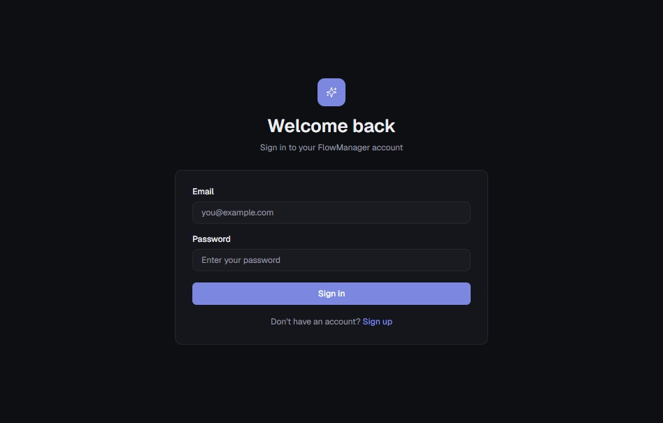

2.1 Logging In
- Navigate to the application login page at https://code-phoenix-productivity-toolkit.vercel.app/login.
- Enter your registered Email address and Password.
- Click Sign in to access your dashboard.

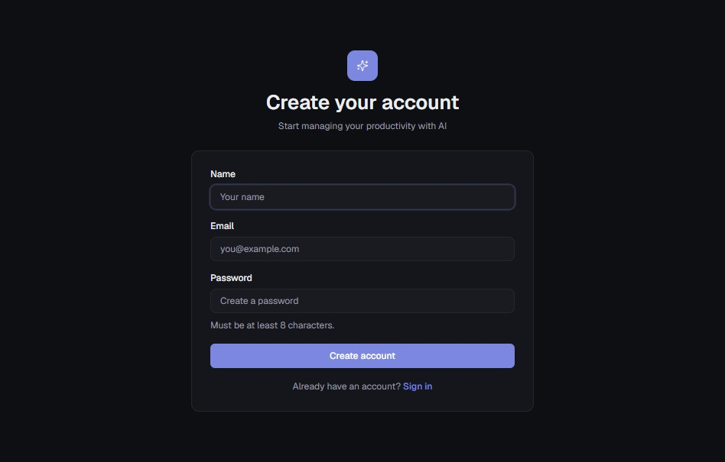

2.2 Account Registration
- If you do not have an account, click the Sign up link on the login page.
- Enter your Name, Email, and a strong password (minimum 8 characters).
- Click Create account to finalize registration and enter the application.

3. Daily Dashboard: Timeline & Agenda Views
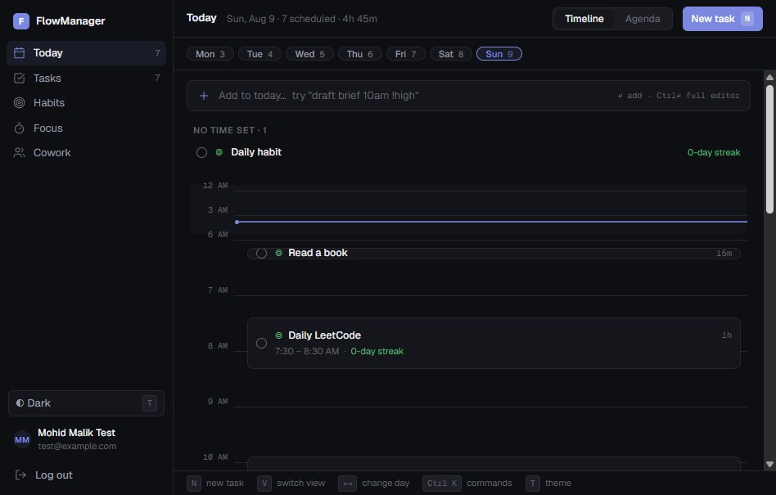

3.1 Overview of the Today Dashboard
Once logged in, you will land on the primary Today dashboard. This view provides a full layout of your scheduled activities for the selected date.
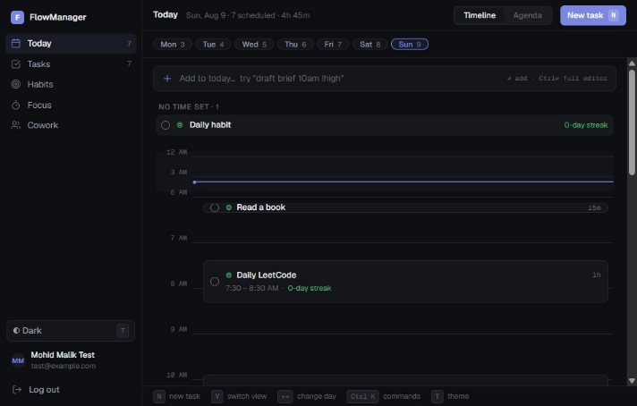

3.2 Unscheduled Items ("No Time Set")

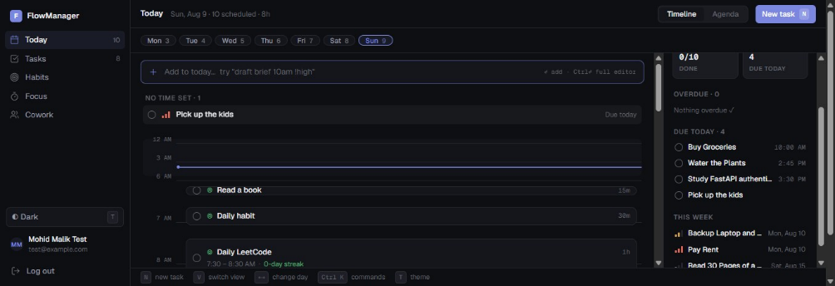

Any active habit or task scheduled for the day that lacks a specific time preference will appear at the top of the interface under the No Time Set section (consider the above two screenshots, one showing an unscheduled habit which is active on the day and the other show a task due today which has not been scheduled).

3.3 Scheduling Tasks & Habits on the Timeline
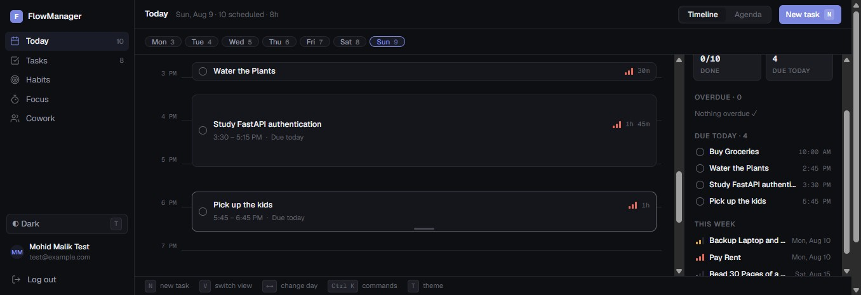

- Time Blocking: Drag and drop any item from the No Time Set container directly onto the vertical timeline grid. You can also drag tasks from the right sidebar, showing overdue tasks and tasks due later to schedule them today, or the chosen day in the timeline.
- Duration Adjustment: Drag the bottom edges of a task/habit block on the timeline to lengthen or shorten its allocated time block.
- Recurring Sync: Daily/weekly habits placed on the timeline automatically reflect on subsequent active days at the same scheduled time, but weekly habits only need to be completed once, and get marked done for the complete week.

3.4 Switching to Agenda View
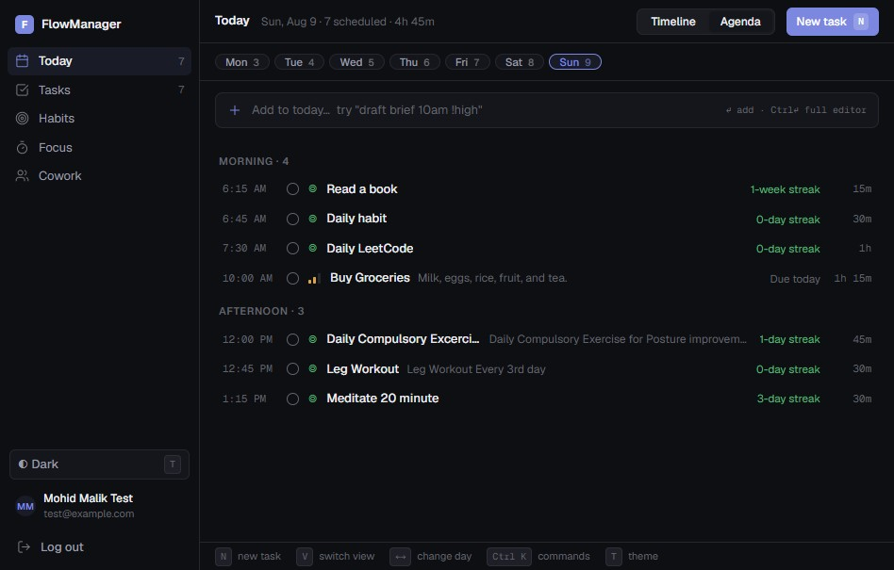

If the visual timeline feels cluttered, click the Agenda view toggle in the top-right header. Agenda view presents your day in a clean, chronologically sorted list categorized into time blocks (e.g., Morning, Afternoon, Evening).

4. Task Management Module

4.1 Quick Task Creation via NLP
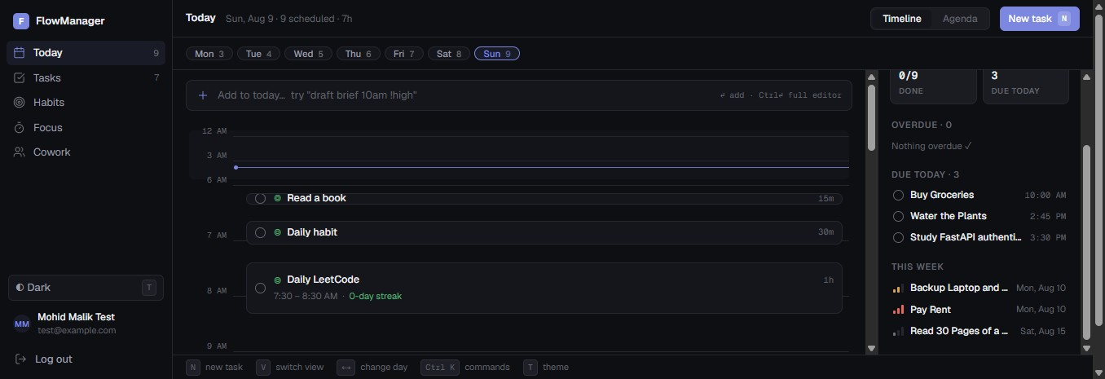
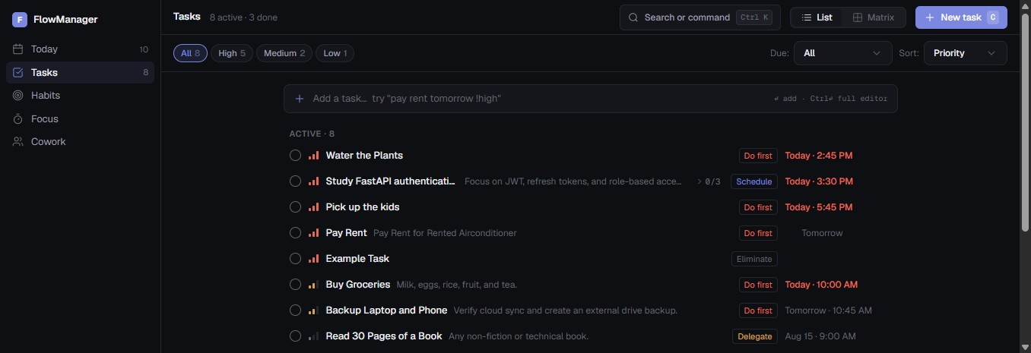

You can quickly add tasks using the inline natural language input field located at the top of the timeline or task view:
- Click the input bar displaying + Add to today... or + Add a task.
- Type your task description along with priority flags or natural temporal expressions (e.g., Pick up the kids !high or Book a flight for James tomorrow).
- Press Enter. The natural language parser automatically interprets priority flags (!high, !medium, !low) and due dates (e.g., Tomorrow, Aug 21), assigning them automatically.

4.2 Advanced Task Creation Modal
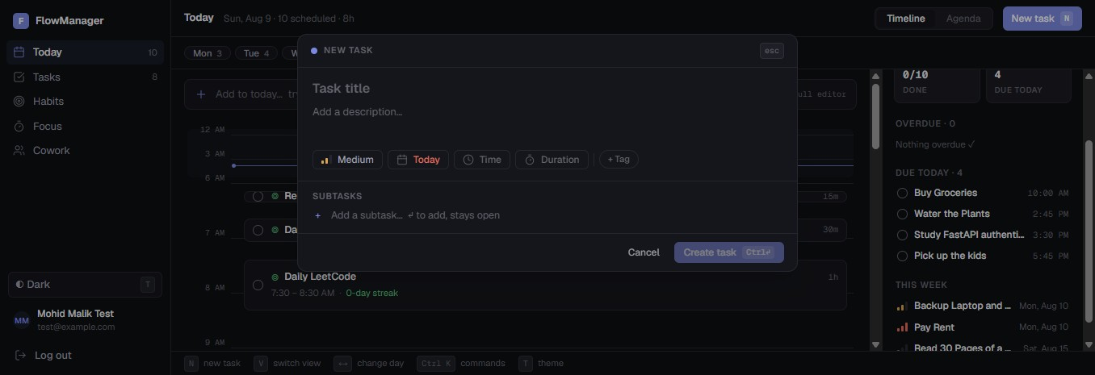

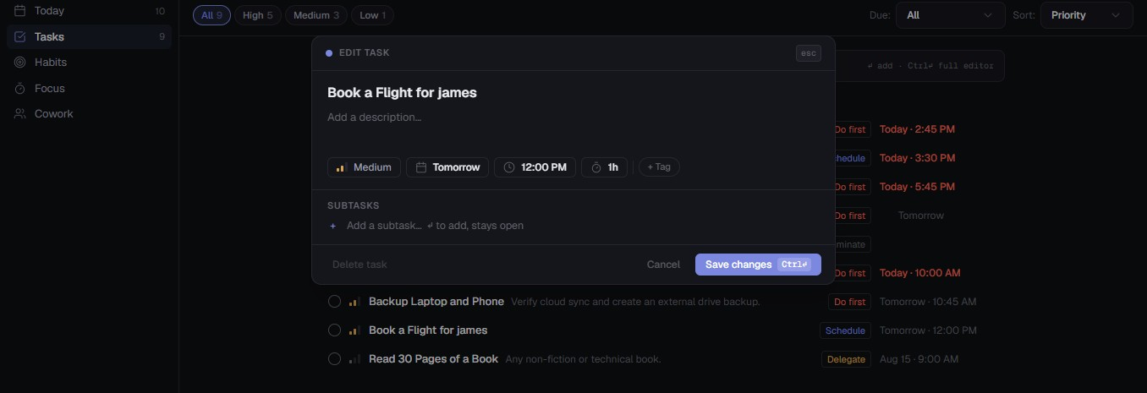

For detailed task configuration, hold Ctrl + Enter while the task input field is focused to open the full task editor:
- Priority: Assign Low, Medium, or High-priority levels.
- Due Date & Time: Select preset dates (Today, Tomorrow, Next week) or input custom dates and times.
- Duration Estimate: Specify estimated effort duration (e.g., 15m, 30m, 1h, 2h).
- Tags & Subtasks: Categorize your task with tags and break it down into actionable subtasks.

4.3 Managing Overdue & Upcoming Tasks
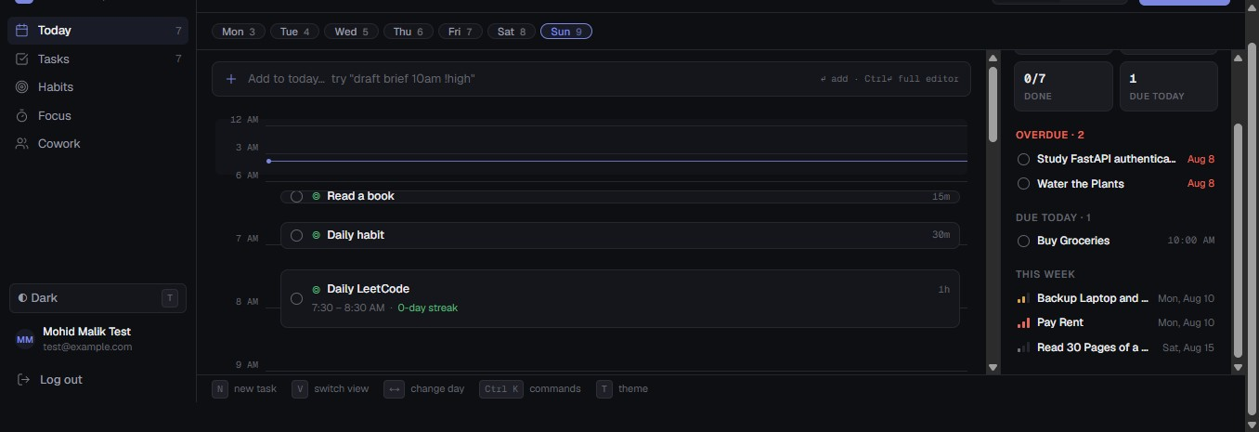

The right sidebar on the Timeline/Agenda dashboard displays a overview of your workflow status:
- Overdue Tasks: Displays tasks with past deadlines highlighted in red. Drag and drop overdue tasks onto today's timeline to reschedule them immediately.
- Due Today & This Week: Provides quick visibility into immediate upcoming commitments.

4.4 Editing and Completing Tasks
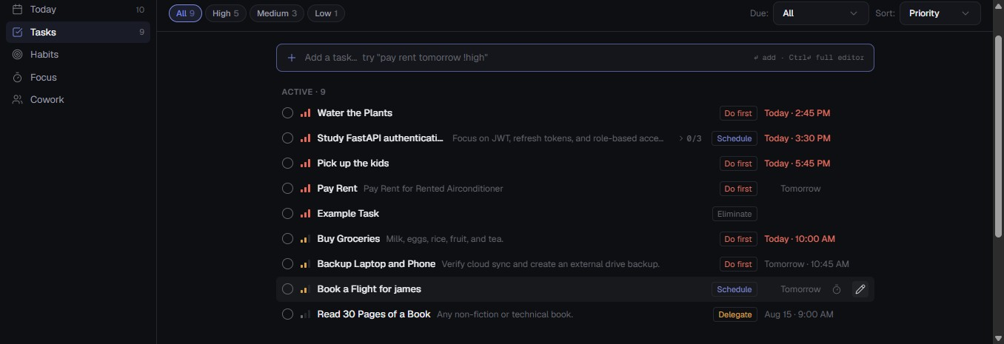

- Editing: Hover over any task item and click the Pencil (Edit) icon to open the edit modal, modify attributes, and save changes (like updating the due date).
- Completion: Click the circular radio button next to any task to mark it complete. Completed tasks move into the Completed list section.

4.5 Eisenhower Matrix View
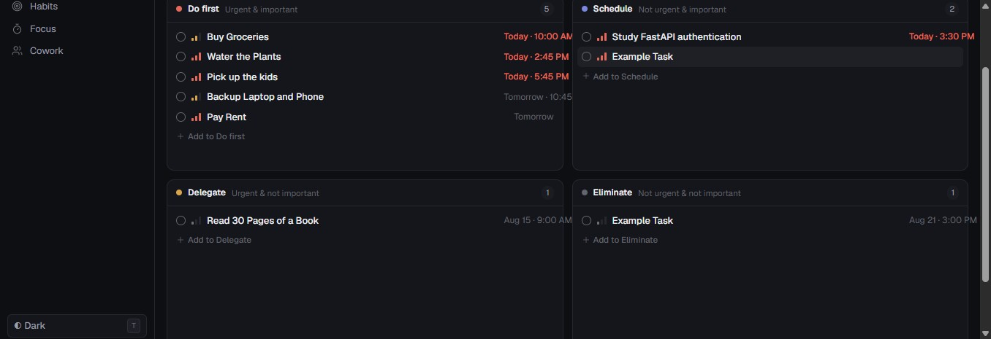

To prioritize tasks using the decision framework, toggle to the Matrix view in the Task Management module:

Quadrant | Urgency / Importance | Action
Do First | Urgent & Important | Immediate execution required.
Schedule | Not Urgent & Important | Assign a specific time block on your calendar.
Delegate | Urgent & Not Important | Assign to team members or automate where possible.
Eliminate | Not Urgent & Not Important | Review for potential removal or archiving.

The system automatically categorizes your tasks into these four quadrants based on priority and due dates. You can manually adjust task classifications by clicking Auto-categorize or dragging and dropping task cards between quadrants.

5. Habit Tracking Module

5.1 Habit Types & Schedules
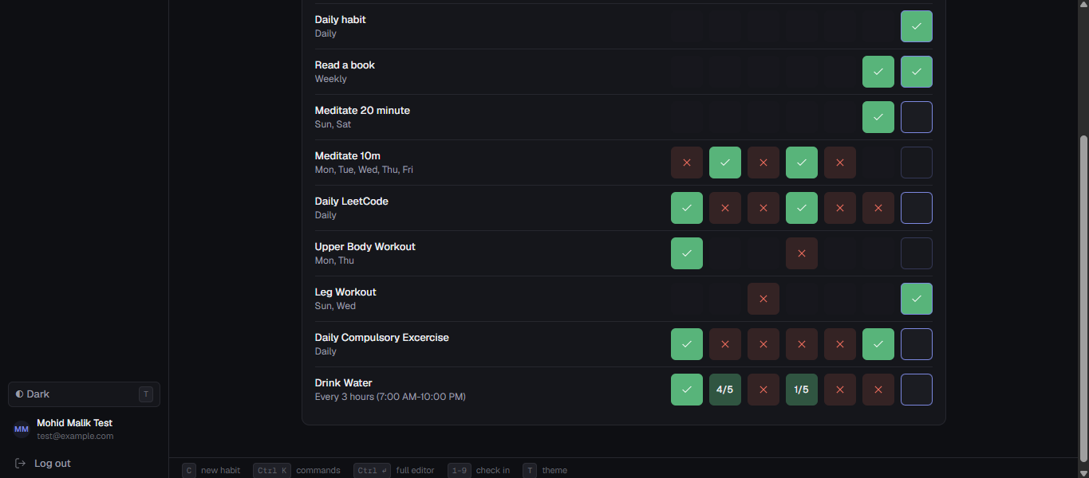

Access the Habits module from the left navigation bar. Code Phoenix supports three habit tracking frequencies:
- Hourly Habits: Repeat across specific recurring hourly windows throughout active hours (e.g., Drink water every 3 hours between 7:00 AM and 10:00 PM).
- Daily Habits: Performed once per day on designated days of the week.
- Weekly Habits: Performed once or a specified number of times per week.

5.2 Adding and Editing Habits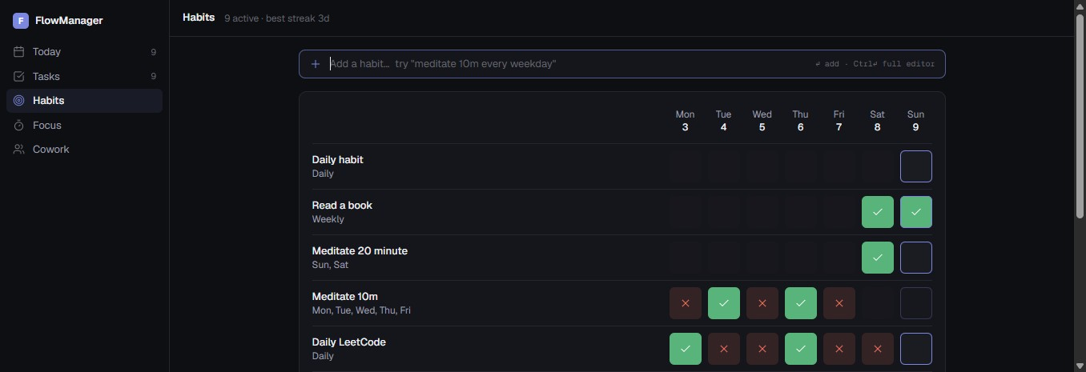
- Quick Add (NLP): Type in the habit field (e.g., Wash the bike every Friday) and press Enter.
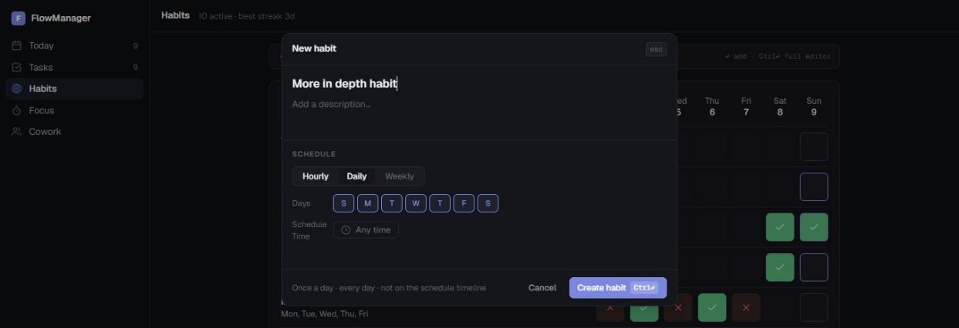
- Full Modal Setup: Focus the input bar and press Ctrl + Enter to configure schedule frequency, active day selectors, time preferences, and custom descriptions.
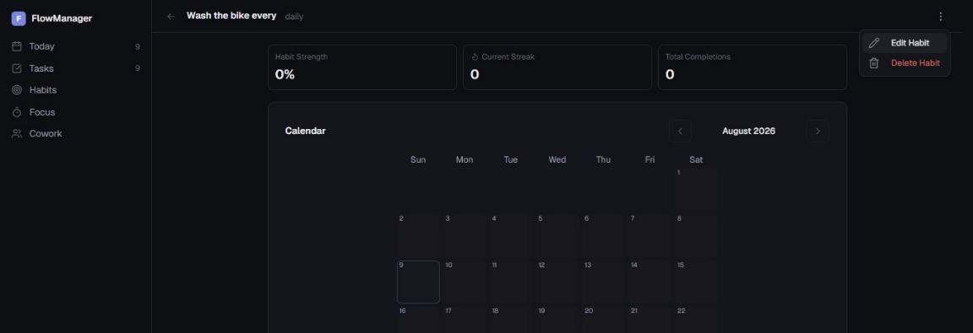
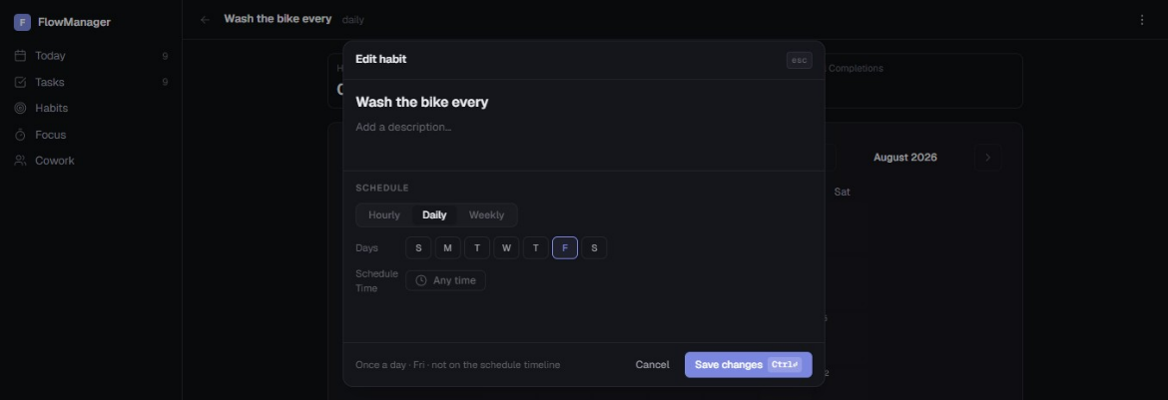

- Editing Habits: Select a habit, click the three-dot action menu in the top-right corner, select Edit Habit, make adjustments, and save. Here in this case, the NLP did not extract the name properly so it simply named it Wash the bike every, we edit it remove every and save the habit.

5.3 Logging Habit Completion
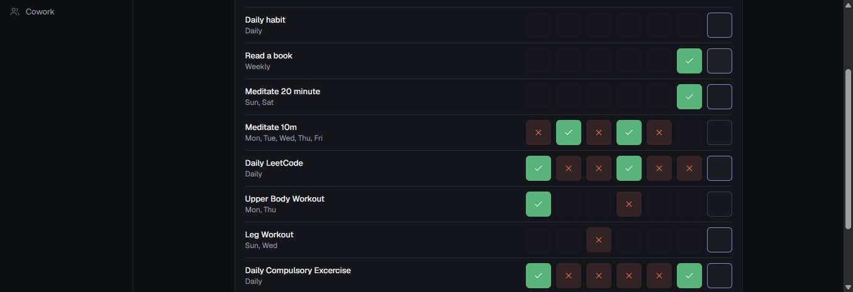

- Inactive days or hours outside scheduled habit windows are greyed out automatically.
- Click the occurrence box for a given day to mark it complete.
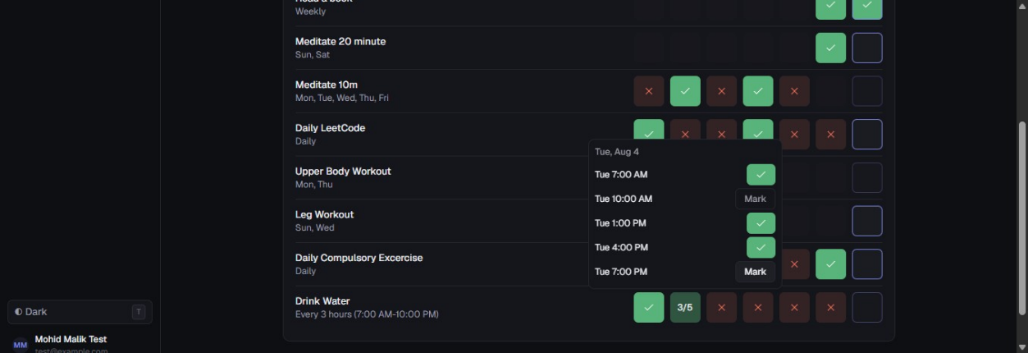

- For hourly habits, clicking the cell reveals a popup menu with specific check-in time windows for precise logging.

5.4 Analytics and Streak Tracking
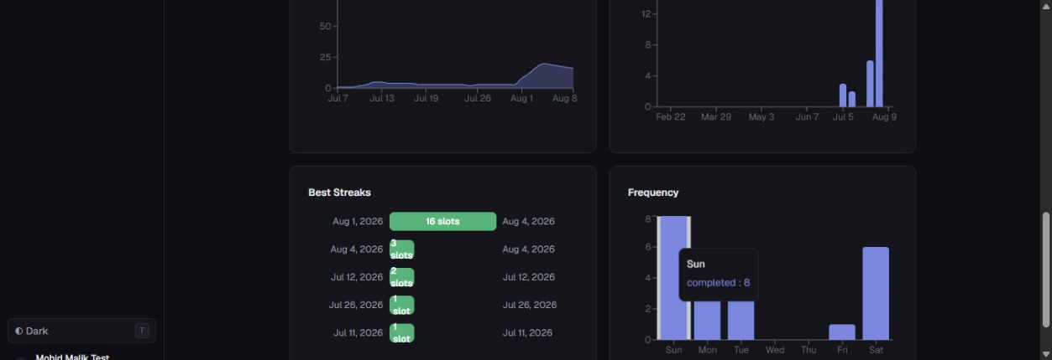

Click on any habit entry to open its detailed performance view, featuring current and longest completion streaks, total completion counters, frequency graphs, and monthly calendar heatmaps.

6. Focus Sessions Module

6.1 Overview

The Focus Sessions module provides structured work intervals (Pomodoro technique) combined with real-time task and habit execution tracking.

6.2 Setting Up a Focus Session
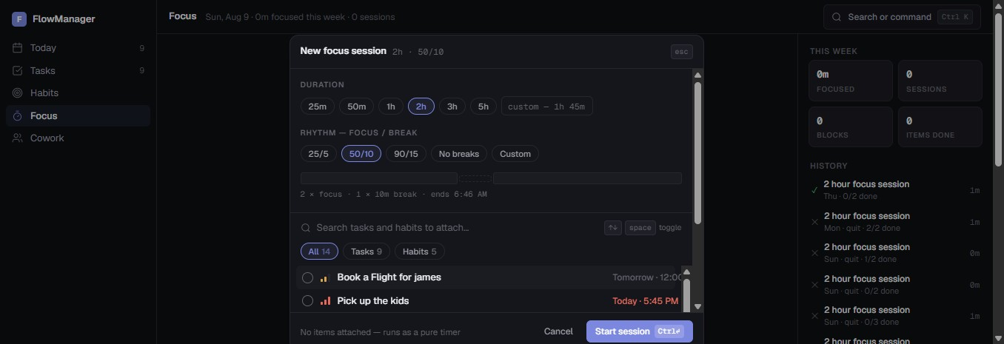

- Click Focus on the left navigation sidebar.
- Click Start focus session.
- Configure Duration: Choose total session duration (e.g., 25m, 50m, 1h, 2h, or custom).
- Configure Rhythm: Select Focus/Break ratios (e.g., 25/5, 50/10, 90/15, or No Breaks).
- Attach Items: Select tasks and habit occurrences from the list to include in the session queue.
- Click Start session.

6.3 In-Session Controls & Management
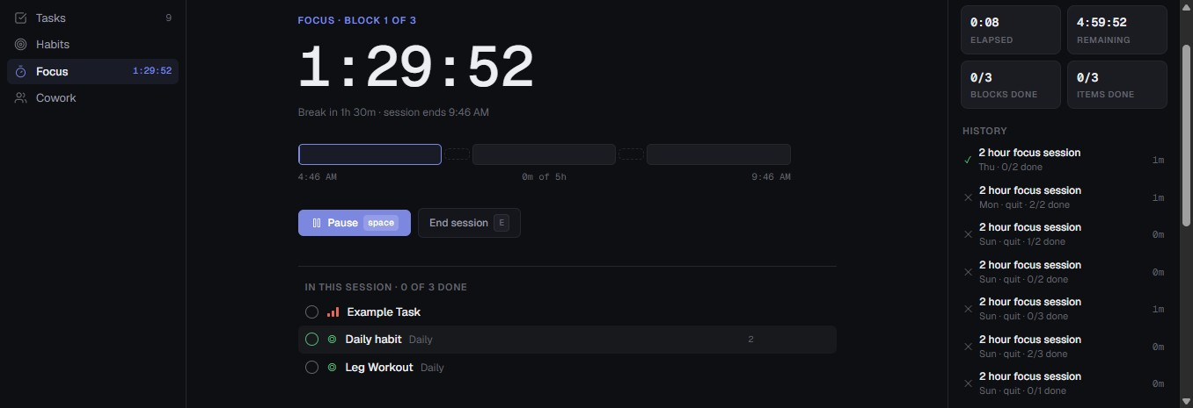

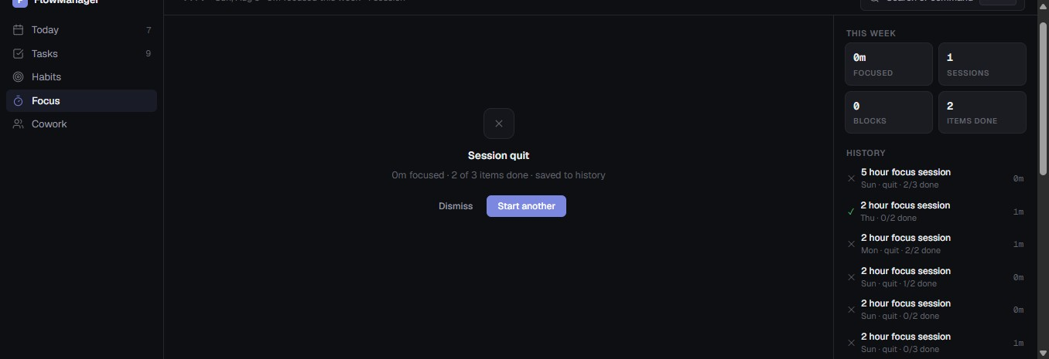

- Timer View: Displays current focus block elapsed time and remaining duration.
- Completing Items: Mark attached tasks or habits complete directly within the focus dashboard. Updates sync automatically across all application modules.
- Pause / Resume: Click Pause or press Space to temporarily freeze the timer.
- Ending / Quitting: Click End session to complete or quit early. Session analytics and items completed are automatically recorded in your weekly history.

7. Coworking Module (Virtual Body Doubling)

7.1 Overview
The Cowork module offers real-time virtual rooms designed for body-doubling productivity sessions with teammates and peers. Room links remain valid for 24 hours.

7.2 Creating and Joining Rooms
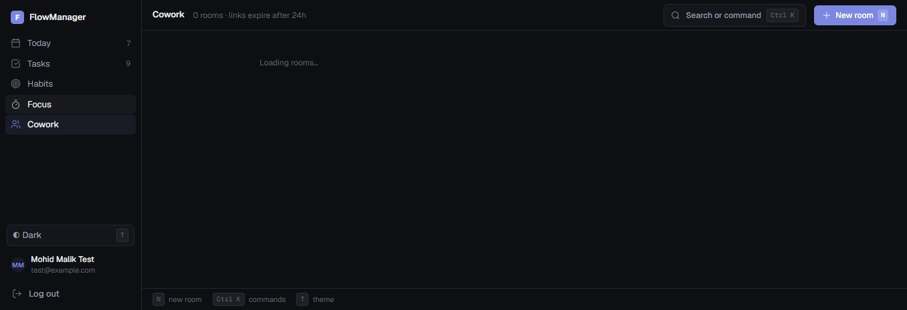

- Click Cowork on the left navigation bar.
- Click New Room.
- Enter a room title (e.g., Test Room or Project Sprint) and click Create Room.
- Click Copy Link to share the room URL with peers. Collaborators can join directly using their FlowManager account.

7.3 Room Controls & Task Sharing
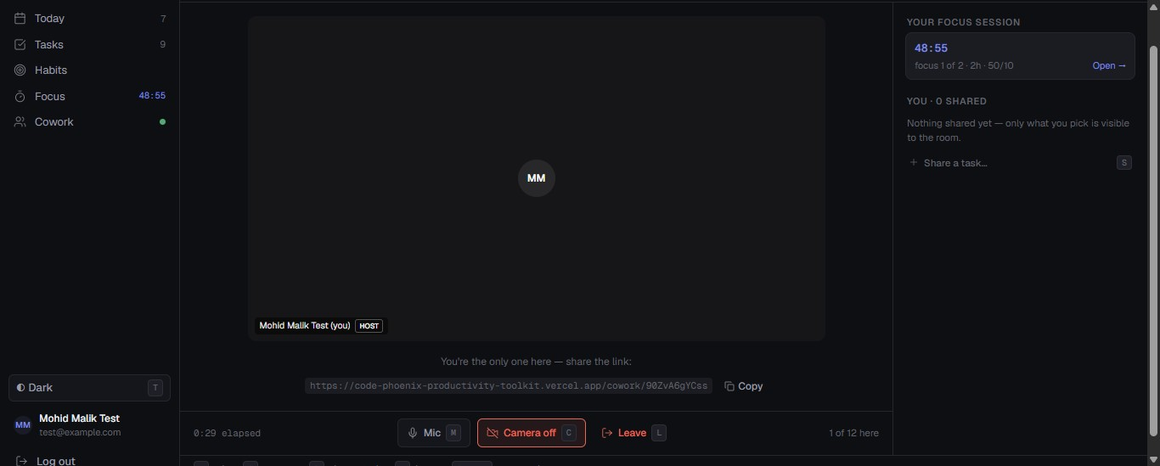



- Media Controls: Toggle your camera and microphone on or off, or leave/end the room at any time.
- Task Sharing: Click Share a task to select active tasks from your list. Other room members will see what you are working on and receive updates when you mark tasks complete.

8. Profile & System Settings

8.1 User Profile
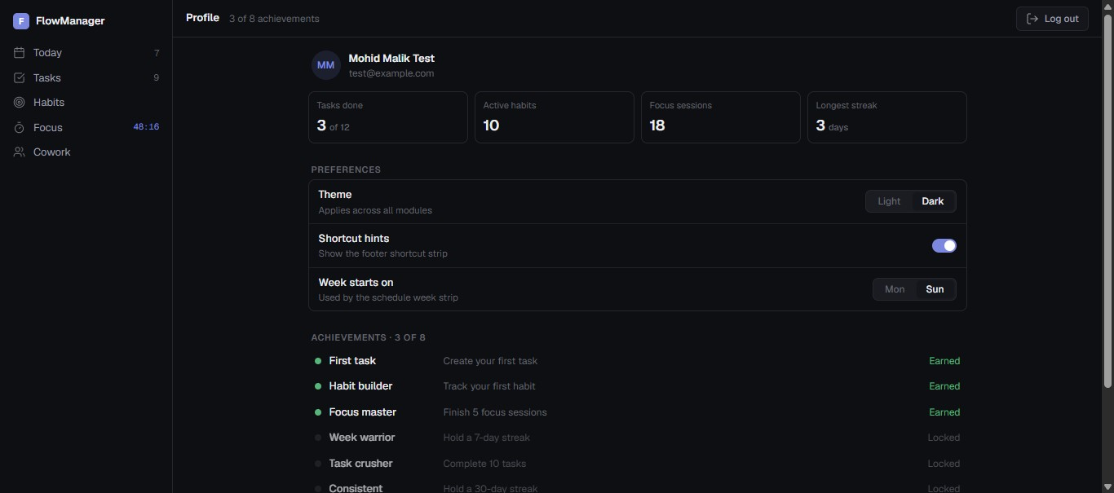

Click your account name at the bottom of the left sidebar to access your profile settings, view active habits, total focus session stats, and unlock productivity achievements (e.g., First Task, Habit Builder, Focus Master, Task Crusher).

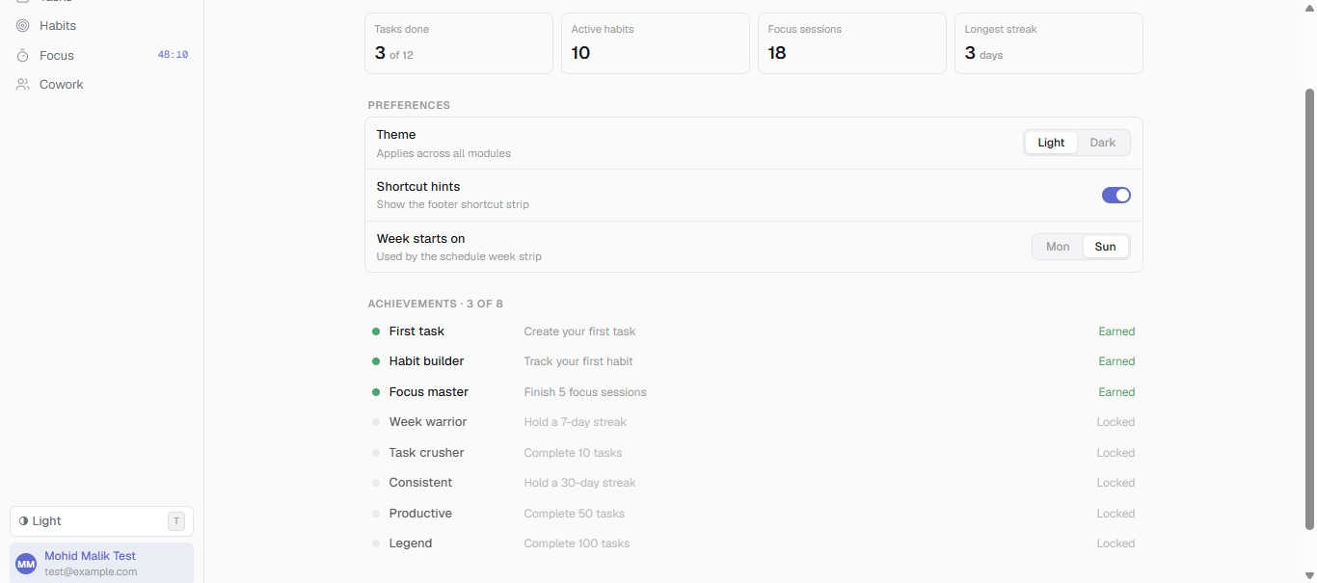

8.2 Theme Preferences & Shortcuts
- Theme Toggle: Switch between Light and Dark visual modes by clicking the theme toggle button in the sidebar or pressing T.
- Week Start Preference: Customize whether your weekly timeline starts on Sunday or Monday.
- Keyboard Shortcut Hints: Enable display overlays for quick application navigation.

